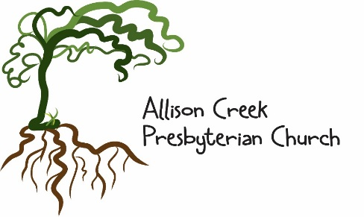

“Making Connections: Personally, Locally, Globally”

Our Core Values:

Creativity: “In the beginning, God created….” - Genesis 1:1
“Creativity requires the courage to let go of certainties.”- Erich Fromm

Authenticity: “By the grace of God I am what I am.” - I Corinthians 15:10
“To find yourself, think for yourself.” - Socrates

Neighborly: “You shall love your neighbor as yourself.” - Leviticus 19:18
“In appreciating our neighbor, we're participating in something truly sacred.”
- Mr. Fred Rogers

Diversity: “There are varieties of gifts, but the same Spirit. There are varieties of services, but the same Lord.” - I Corinthians 12:4
“Our ability to reach unity in diversity will be the beauty and the test of our generation.” - Mahatma Ghandi

Visionary: “Where there is no vision, the people perish.” -Proverbs 29:18
“Desire has to do with what we want. Vision has to do with what we need.”
- Sister Joan Chittister

Integrity: “We intend to do what is right not only in the Lord’s sight but also in the sight of others.” - 2 Corinthians 8:21
“The time is always right to do what is right.” – Dr. Martin Luther King, Jr.

Service: “It is more blessed to give than to receive.” - Acts 20:35
“The good you do today will often be forgotten. Do it anyway.” - Mother Teresa

